

|  |
| --- |
| Science Communication as a Live Performance. 50546. |
| Module Lead: Professor Andy Miah.  Word count: xxxx |
| Student name: Hannah Lacey  Student Number: @00543088  Submission date: Tuesday 15th January 2019, 4pm |
|  |





|  |  |  |
| --- | --- | --- |
| Critical Evaluation: science communication as a live performance. |  |  |
|  |
| **Introduction**  The piece of science communication, which I have produced for this module and will be evaluating, is entitled:  Feathers and Fur Falconry Centre; Saving the Kestrel*.*  And can be accessed here:  <https://www.youtube.com/watch?v=fEOqr8GqKxY&list=PL9fZnc6lH7HVxI-aeKxXTf1uoEm6qDk7d>  (Lacey, H 2019)  This is an original production created for assessment and additionally for use as Feathers and Fur Falconry Centre see fit on the understanding they credit myself.   This is a 14-minute video where I, Hannah Lacey science communicator, talk to Sadie Shepherd owner of Feathers and Fur Falconry Centre (FFFC) in Reading, about the difficulties that Kestrel’s face, and how “we” (audience members, those with an interest in conservation, or birds of prey) can help the iconic British bird.  It is important to highlight that this submission has not been edited beyond being topped and tailed where the live performance would start and conclude and this has been recorded “as live”.  This is a test to see if it continues |
| Suitability of platform:  Although that for the purpose of this submission the live performance has been placed onto YouTube, in the ideal world this would have been placed on FFFC’s social media channels. One of the reasons I wanted to work with the Centre was due to their outward facing promotion on social media, which can be seen in Appendix 1.  FFFC’s social media approach is cross-platform and, in my opinion tailored well to their audience; they know what works and gets them views, interactions, and from what we can assume leads for visitors, sales and donations. For someone such as myself who has an interest in birds of prey conservation; this highlights a perfect partner for science communication.  Many academics have highlighted the importance of ensuring you have the right platform for targeting your audience; and ensuring your audience has access to this platform. Although in this instance I focus on social media platforms, this is equally important for more “traditional” forms of media such as radio and television broadcast. McQuail (1997) has covered this idea explicitly in his research “we need also to recognize the actual audience for broadcasting, the one that is present for a particular “program”.  Due to the strong social media presence, it made sense for this video (if it was to be broadcast as live) to be on FFFC’s live social media channels. In the ideal world this would have complimented what seems to be their most popular social media channels of Facebook (Feathers and Fur Falconry Centre, 2019) and Instagram (Feathers and Fur Falconry Centre, 2019) through Facebook Live and / or a live video on Instagram. If FFFC had an established audience on Twitter, using applications such as Periscope would have also been considered.  It’s important to note that this assumption is made from what is publically available to see on these social media networks as I am unable to get access to FFFC’s social media analytics, which would reveal greater information about audiences, engagement rates and impressions which would further inform and develop any live performance approaches for the Centre and myself. If FFFC’s chose to publish the video on their own social media channels it would be interesting and highly valuable to access the analytics, comments and any feedback from this.  The impact and suitability of this is difficult to evaluate as this is being constructed on a purely hypothetical approach. However, one can assume from personal experiences on social media, that this may have been a beneficial choice of platform as it is broadcasting where the audiences is.  The opportunities that social media offers, in that audiences use social media as a “go to” for information, utilizing its on-demand characteristics highlighted by Mangold and Faulds (2009), is certainly something that I believe strong science communication should capitalize on and again reaffirms the ideology of using social media platforms, especially those that are already developed for a specific audience and message.  This approach can also be backed up by the continuation of FFFC to create and post original content; I assume that if this wasn’t beneficial they would not use limited resources to create the content and update social media as frequently as they do. Looking back at this, I would not change my approach of what platform I would use, apart from trying to gain greater insight into the real social media analytics of FFFC.  Quality of delivery:  When looking back at the delivery of the video, there are multiple elements that I am choosing to evaluate upon for this evaluation; this is by no means the limit of the evaluation nor points to be considered but simply a starting point.  Picture and audio quality  As in the ideal situation this video would have been recorded for Facebook Live or Instagram Live; the chances are this would have been conducted on a smartphone. To replicate this, I filmed the conversation with Sadie on my Apple IPhone 8, using the inbuilt video mode. With this, in comparison to a professional camera and audio recording set up, naturally, limits the quality of the video and audio. However, as many “non media professionals” are posting content online this quality is perfectly acceptable for social media posting.  Web 2.0, which is the definition of this this new stage of internet development and ways of using “on demand”, portable, interactive media (Branston & Stafford, 2010) is becoming increasingly common and automatically associated with social media use. As mentioned above, as web 2.0 is taking over posts on social media the quality appears to be no longer an issue for audiences, with the more “rough and ready” approach doesn’t seem to turn them away, this can also be seen to be helped with the development of technology; the quality of what can be produced without professional equipment, means that the “rough and ready” approach is actually still of a high, broadcast quality.  Analyzing the video quality, although for this instance the quality is more than substantial, the perfectionist in me would love to see a recording with a sharper image to give a more professional finish. However, with file size limits for social media uploads (and interest speeds) this is something, which, even if I did have higher quality video footage, I may have had to lose for practicality purposes. Looking back at this, I am content with the quality that would be expected by audiences with a live video, however, if I was able to redo this video it would be beneficial to find a smartphone with a higher quality camera  Looking back at the video and audio quality, I am more than happy with the outcome. The only issues, which could be improved, are items that are *almost* out of my control. Being based in Reading the Centre falls under a flight path to Heathrow airport; through the video you can hear distant aircraft, although this is something that even professional recording equipment would still pick up; filming outside in a Kestrels natural environment this is a trade off that I was willing and happy to accept for the aesthetics and relevant location.  Another sound issue, is that the paper script / running order can be heard at points rustling (which was taped to a chair below the phone recording for ease of myself and Sadie whilst recording). This would be avoidable in the future by again a change of location to become more sheltered from the wind, however, again this is a trade off for aesthetics and relevant location that I was happy to make. Another approach would be to adapt a different approach of having a running order visible. However, this doesn’t distract too much from the recording but in the future is something I would work on removing and/or reducing the possibility of happening.  Script / speech quality  When looking back over the video performance the conversational style and tone of the piece makes for an almost BBC Springwatch (BBC ,2018) style production. This, when broken down consists of an interview style conversation, where the interviewer also adds comments and information to the conversation rather than just to ask questions. This style has also been adopted for politicians and their approach “presenters are telling their stories seated in an armchair, discussing their ideas with an interviewer” (Forbes, 2016). This shows that not only entertainment but more informational content can benefit from this somewhat, laid back approach.  This, for me, is an accomplishment as I aimed to balance the communication as informative, but laid back and approachable. I wanted the science communication to be done in such a way as to not intimidate, or put off the audience. This is something, which the BBC produces well with not only Springwatch (BBC, 2018) but other such targeted shows (informative, yet entertaining) such as The One Show (BBC, 2019).  From the other perspective, the use of social media and making science research approachable can contribute to a researchers scientific impact (Xuan et al. 2014). This is of significant importance for researchers; as in my opinion, all research should be accessible and of interest to “the public”, and from a grant reporting perspective this allows researchers to evidence how their research has had impact (through pathways to impact).  Personally I would not change the style and tone of the video, informal feedback which I have received from those who have watched the video includes comments saying it’s very similar to the BBC programs, short and easy to watch whilst being interesting. For me this highlights that I’ve managed to achieve the right balance that I was aiming for.  Performance quality  As a media production graduate this is a new aspect for me to be focusing on. In previous education and experience I have either been behind the camera / microphone or journalistically interviewing someone. To think as myself as a performer has been a totally new concept and one that I have spent a lot of time thinking about in the run up to this production.  Taking this into consideration I deliberately chose to create a video on a subject matter, which I had a personal interest and some knowledge in; this was the basis of wanting to work with FFFC. From enjoying shows such as BBC’s Springwatch (BBC, 2018), I took this as inspiration for matching my journalism to entertainment.  This infotainment (information and entertainment) approach has been increasingly adopted within mass communication, Branston and Stafford highlight that “media forms have consequently become more and more cross-generic or hybrid or “mashed” as advertisers seek to attract more and more small segments of what used to be called ‘the audience’” (2010, pg 81).  As a communicator and performer in this instance its important for the presenter to appear confident in what they’re doing; and from tailoring this to my strengths I feel this came across in my professionalism and conversation throughout the performance.  I think the biggest way that I could improve my approach here, is to dedicate more pre-production time to learning about the topic to enable a more conversational style approach. However, for me personally this is a difficult, fine line to balance, I was conscious of not wanting to “step on anyone’s toes”. For me when speaking with someone who is a subject matter expert it’s not “informatically” correct, nor polite to try and have a conversation to appear that as the interviewer you know as much as, or more than the professional. Personally for me, this isn’t the way I wish to come across as a science communicator. This is a balance that I could look at again for future performances and initiate in depth discussions with interviewees to see how this correct dialogue can be created.  I also think the above point is very important as audiences may not be tuning in to listen to me as science communicator; but through me access the specialist in the field. As approached through other topics on my Msc this places me in a facilitator role, which is how I see myself as a science communicator; facilitating the audiences connecting with the specialist.  Quality of staging:  As already mentioned in this evaluation creating the right environment for the performance was critical for me. Getting this right included working with Sadie at FFFC to think about how best to showcase the kestrel, and the available spaces on site. This came with its own set of challenges; filming outside in December in England we had to prepare for outside and inside eventualities for filming.  Location  As mentioned above with my chosen style of live performance, having a relevant location was key to the production. Working with FFFC I was luckily aptly placed in an environment where you would either find kestrels and other native birds of prey; but also had access to flying arenas that the Centre used regularly.  Fortunately on the day of recording the weather was nice and we were able to record outside in the flying arena. Not only was this picturesque but also offered a comfortable, known environment, for the kestrel Bournville who was also taking part in the recording.  Again, on reflection I am happy with the informal setting this offers the viewers. As a science communicator I am unsure of the benefits of conversations and interactions taking place in a TV studio or science lab etc. are beneficial as it’s unlikely to be a location that “the general public” would be present in. However, the location of a field outside a town, is much more relatable to audiences. Creating this level of comfort is important, in my opinion, in removing these barriers.  Looking back at this video, going forward I would think about possibly having something more interesting or interactive in the background, but done to the level where it would not take the viewers attention away from the main conversation. Also trying to find a location, not under the Heathrow flight path would be beneficial.  Props  For me the use of props is something that has to be relevant to the production and messaging. Through the video there was 3 main props utilized; all with there own specific rationale.  Sofer (2003,) defines the role of the prop as to “seduce our attention […] as they become drawn into the stage action and absorb complex and sometimes conflicting meanings. By Definition a prop is an object that does on a journey”. In this instance, the use of the prop is not to seduce the audiences attention, but to help develop the meaning that Sofer mentions, and with my choice of props I aimed for them to help develop the narrative and to support the audience member on their journey through the performance by adding another layer of interest. Bournville the kestrel Bournville, was the main prop used within the production of the “as live” video. To clarify at this point, Bournville was not harmed in the making of this video and his welfare was upmost importance. I discussed with Sadie owner of FFFC and she ensured me that she had all relevant licenses for keeping and performing with the birds of prey. I also researched this myself to ensure that I would not be encouraging anything unethical during the production of this video. (RSPCA, 2019)  I decided that using Bournville as the main prop for the short video was the most appropriate approach. As Sadie and myself would be discussing the bird and his characteristics it seemed appropriate to be able to show this to the audience watching the video so they could clearly see the aspects mentioned such as markings and eyes. As mentioned in the production a kestrel is a bird of prey which many people recognize the flying pattern of at the sides of roads; therefore giving them the opportunity to get “up close and personal” which a bird you may only see from your car was an excellent way to engage with the audience.  If I was to record this video again I would look into ways of possibly getting a female kestrel on set to be able to show the differences between the genders of the bird, however, this would only be of benefit to one point made in the conversation, and therefore the lack of this added prop for this performance was not to the detriment of the production. Kestrel skull and box The use of the kestrel skull and nesting box fell secondary to the use of Bournville in props. These were used to help audiences visualize comments that Sadie and myself were making. These are props, which personally, I feel that the show could have continued without, but were nice to have to break up the constant conversation.  In an ideal production the kestrel skull, which was kept in a plastic box did make it difficult to see, would be free to be held by either Sadie or myself. This would have not only made it easier for us to be able to compare it to Bournville but also enable it to be held up to the camera and seen more closely by those watching the video.  On the other hand the kestrel box, although not as interesting visually as the other props, served well in its purpose. I do not think that any more focus on the empty box would have brought value to the live performance. If it was technically possible to cut to a live kestrel nest camera feed during the live performance (as frequently seen in Springwatch (BBC, 2018)) this would have added value.  Quality of structure:  Narrative of performance  When planning and developing the content of the live performance with Sadie from FFFC, finding a natural narrative flow was an important aspect for me. As a science communicator I believe that a strong narrative can help immerse audiences and capture (and more importantly keep) their attention.  Gauntlett (2008, pg.118) clearly explains that audiences “come to expect strong, clear narratives” and also believes that “stories provide an opportunity for individuals to think about the kind of person they want to be”. (2008, pg. 272). From this academic perspective its clear to me that, to an extent, the production should comply with a clear narrative that audiences are used to seeing. His follow up point regarding self-reflection for audiences is equally important with such a production that is requesting audiences to think about the conservation of the kestrel and how they can take personal action to help.  Therefore working with Sadie and having conversations about the topic, we shortlisted ideas to discuss in the life performance in relation to what was the most important. From here we then molded the ideas to see how they would naturally flow, rather than the performance having a segmented feel. From this a natural topic narrative evolved and those ideas, which felt like “add on” conversation topics, were dropped.  Upon reflection I feel this was a strong way to develop a relevant and compelling narrative that was not strict and allowed the conversational feel of the performance. The subject matter and flexible brief added to this ease of narrative creation, for future productions a more strict and planned approach might be necessary to enable the messages to be communicated well.    Bibliography  BBC (2018) *Springwatch* [Television Programme] London: BBC  BBC (2019) *The One Show* [Television Programme] London: BBC  Branston, G, Stafford, R (2010) *The Media Student’s Book*. (5th edition). London: Routledge.  Feathers and Fur Falconry Centre (2019) *Feathers and Fur Falconry Centre YouTube.* Retrieved from: <https://www.youtube.com/user/FeathersandFur1/videos>  Feathers and Fur Falconry Centre (2019) *Feathers and Fur Falconry Centre Instagram Page*. Retrieved from: <https://www.instagram.com/feathers_and_fur_falconry/>  Feathers and Fur Falconry Centre (2019) *Feathers and Fur Falconry Centre Website*. Retrieved from: <https://feathersandfur.co.uk/>  Feathers and Fur Falconry Centre (2019) *Feathers and Fur Falconry Centre Facebook Page*. Retrieved from: <https://www.facebook.com/Feathersandfurfalconrycentre>  Forbes (2016) How To Present A Fireside Chat In Four Easy Lessons. Retrieved from: <https://www.forbes.com/sites/jerryweissman/2016/03/20/how-to-present-a-fireside-chat-in-4-easy-lessons/?fbclid=IwAR1v6AreqgzZZDS7bwHewxPV0fEpmhsFZDCQPYPoTxpRW1rK8FocZRLH7X0#1eace2524951>  Gauntlett, D (2008) *Media, Gender and Identity An Introduction.* 2nd Edition. London: Routledge  Lacey, H (2019, 08, January) *Feathers and Fur Falconry Centre; Saving the Kestrel* [Video file] Retrieved from: <https://www.youtube.com/watch?v=fEOqr8GqKxY&list=PL9fZnc6lH7HVxI-aeKxXTf1uoEm6qDk7d>  LIANG, X., SU, L.Y., YEO, S.K., SCHEUFELE, D.A., BROSSARD, D., XENOS, M., NEALEY, P. and CORLEY, E.A., (2014). Building Buzz: (Scientists) Communicating Science in New Media Environments. *Journalism and Mass Communication Quarterly,*91(4), pp. 772-791. Doi: 10.1177/1077699014550092  Mangold,G & Faulds, D (2009) Social media: The new hybrid element of the promotion mix. *Business Horizons. 52(04).* 357-365. Doi: [https://doi.org/10.1016/j.bushor.2009.03.002](https://doi-org.salford.idm.oclc.org/10.1016/j.bushor.2009.03.002" \o "Persistent link using digital object identifier" \t "_blank)  McQuail, D (1997) Questions of Media Research . *Audience Analysis.* (pp. 43 -64) London: SAGE Publications.  RSPCA (2019) *Performing Animals*. Retrieved from: <https://www.rspca.org.uk/adviceandwelfare/performinganimals>  Sofer, A (2003) *The Stage Life of Props.* Ann Arbor: University of Michigan Press.    Appendices: Appendix 1. Feather and Fur Falconry Centre social media channels: (Feathers and Fur Falconry Centre, 2019) – see Bibliography for full details.Youtube: (below) |

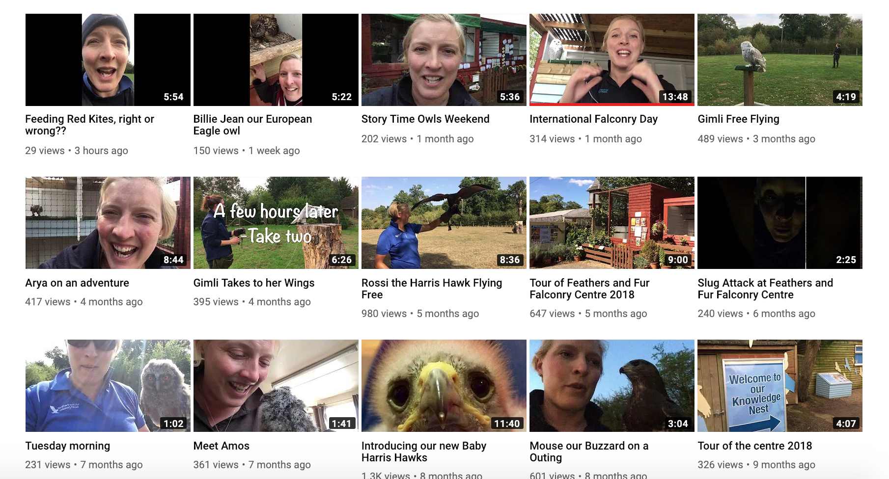

Examples of why I chose to work with Feathers and Fur

# Instagram: (below)

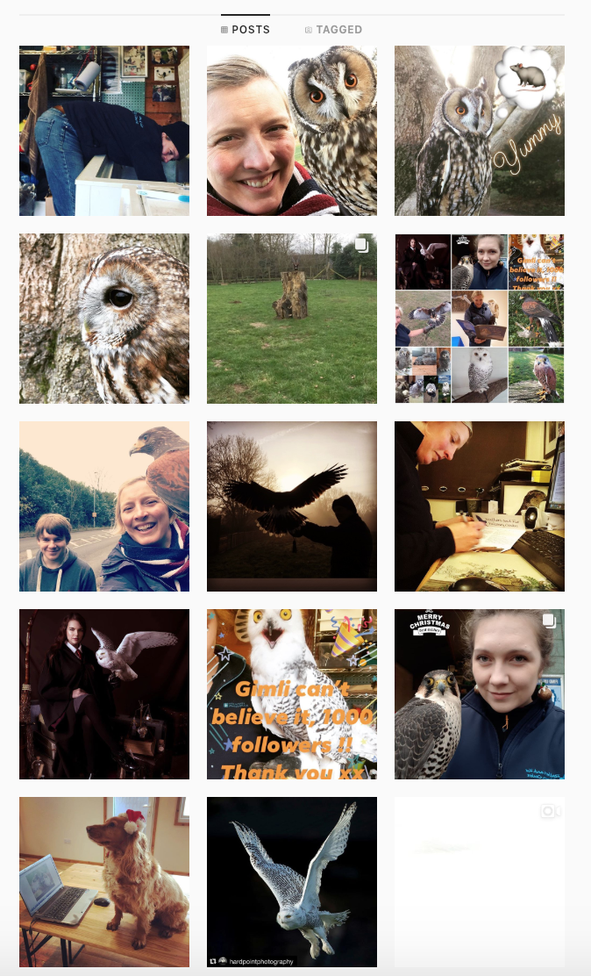

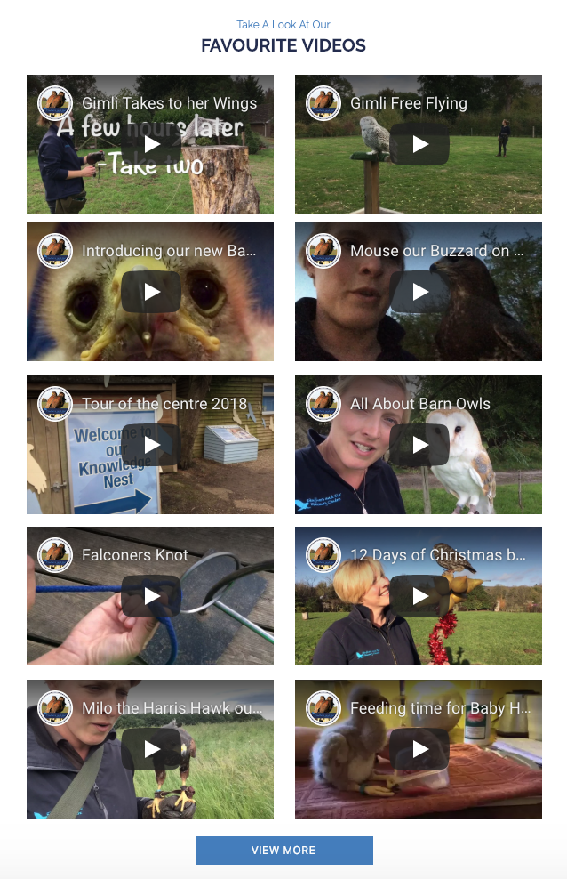

Examples of why I chose to work with Feathers and Fur

# Website: (above) / right)

# Facebook: (below)

